CHRIS BUTTERS

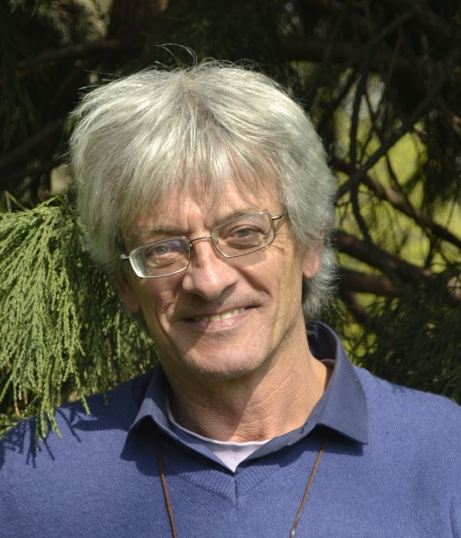
Architect, consultant, lecturer, and widely published author, Chris has 40 years’ international experience in green building and sustainable development. A Norwegian citizen and co-founder of GAIA, he has also lived and worked in France, Britain and Bhutan. Most recently holding a research posting at the School of Engineering, Warwick University, UK, his experience covers both cold and hot climates. Chris is postgraduate course leader on sustainable energy policy, environment and development at Oslo University. He also has a degree in English Literature. Other active interests include organic gardening, painting and music.

Chris says: “Green” was just the natural path to take. Reflection, creativity and commitment; life with head, hands and heart.

Contact info:
phone +44.(0)7904.000051
email chris@butters.no

